Development of resistant starch-enriched cookies using green cavendish banana (Musa acuminata)

Tran Thuy Linh¹ - Dao Thi Thuy Duyen¹ - Pham Thao Nguyen¹ - Huynh Minh Tam¹ - Nguyen Thi Minh Hoa¹ - Nguyen Thi Thuy Hoa¹ - Nguyen Thi Thuy Duong^{1*} -
¹Faculty of Food Science and Technology, Ho Chi Minh City University of Industry and Trade
*Email: duongntt@huit.edu.vn

Abstract:
Green Cavendish bananas (Musa acuminata) are a rich source of resistant starch (RS), yet substantial quantities of non-export-grade fruit remain underutilized. This study investigated the use of RS-rich green banana flour in cookie production. The effects of drying temperature on RS retention were evaluated, followed by flour characterization and an assessment of cookies formulated with different wheat flour substitution levels. Drying at 60 °C yielded the highest RS content (48.75 g/100 g dry matter). Replacing 20% of the wheat flour with green banana flour produced cookies with textural and sensory properties comparable to those of the control and high overall acceptability among 101 participants. Baking at 165 °C for 15 min resulted in cookies containing 15.01 g RS/100 g dry matter - approximately 7.5 times the amount found in conventional cookies and a moisture content of 0.78%. These findings highlight the potential of RS-rich green banana flour as a functional ingredient for producing high-RS cookies without compromising product quality. This approach provides a value-added solution for utilizing non-export-grade green bananas while supporting the development of functional bakery products with potential health benefits.
Keywords: cavendish banana, green banana flour, resistant starch, cookies, functional

Phát triển bánh quy giàu tinh bột kháng từ chuối xanh Cavendish (Musa acuminata)

Tóm tắt:
Chuối xanh (Musa acuminata) giàu tinh bột kháng (RS) nhưng một lượng lớn quả không đạt tiêu chuẩn xuất khẩu chưa được khai thác hiệu quả. Nghiên cứu này đánh giá khả năng sử dụng bột chuối xanh giàu RS làm nguyên liệu chức năng trong sản xuất bánh quy. Ảnh hưởng của nhiệt độ sấy đến hàm lượng RS được khảo sát, sau đó đánh giá đặc tính bột và chất lượng bánh quy ở các mức thay thế bột mì khác nhau. Sấy ở 60°C cho hàm lượng RS cao nhất (48,75 g/100 g chất khô). Thay thế 20% bột mì bằng bột chuối xanh tạo bánh quy có đặc tính cấu trúc và mức độ chấp nhận cảm quan tương đương mẫu đối chứng, với mức chấp nhận cao (n = 101). Nướng ở 165°C trong 15 phút tạo bánh quy chứa 15,01 g RS/100 g chất khô, cao gấp 7,5 lần bánh quy thông thường, với độ ẩm 0,78%. Kết quả cho thấy bột chuối xanh giàu RS có tiềm năng phát triển bánh quy có chất lượng cảm quan tốt, góp phần nâng cao giá trị chuối không đạt tiêu chuẩn xuất khẩu.
Từ khóa: chuối Cavendish, bột chuối xanh, tinh bột kháng, bánh quy


Introduction
Banana (Musa spp.) is one of the most widely cultivated crops in tropical and subtropical regions worldwide (Khoozani et al., 2019). Among commercial cultivars, Cavendish banana (Musa acuminata, AAA Group) accounts for approximately 50% of global production because of its high yield and adaptability (Magon et al., 2026). At the green stage, banana pulp contains 60–70% starch on a dry matter basis, of which 30–50% is resistant starch (RS), making green banana one of the richest natural sources of RS (Munir et al., 2024; Ringer & Blanke, 2021).
Resistant starch escapes digestion in the small intestine and is fermented in the colon to produce short-chain fatty acids that provide multiple health benefits, including improved glycemic control, enhanced satiety, and modulation of gut microbiota (Munir et al., 2024). Consequently, RS-rich ingredients have attracted considerable interest for the development of functional foods.
Green banana flour has been successfully incorporated into a variety of food products. Previous studies have shown that its incorporation improves the nutritional quality of noodles, gluten-free muffins, gluten-free rice cookies, cakes with layers and sponges by increasing RS and dietary fiber contents while maintaining acceptable sensory properties (Munir et al., 2024). However, studies on the application of Cavendish green banana flour in cookies remain limited.
Given the increasing consumer demand for healthier bakery products and the growing global cookie market (Molnar et al., 2023), the development of RS-enriched cookies using green banana flour represents a promising approach to enhance nutritional quality while adding value to non-export-grade bananas. Therefore, this study investigated the effect of drying temperature on the RS content of green Cavendish banana flour and evaluated its application as a partial wheat flour substitute in cookies based on physicochemical, textural, and sensory characteristics.

Materials and methods
  - Materials
Stage 1 green Cavendish bananas (Musa acuminata Cavendish) were supplied by Agenas Production, Trading and Service Co., Ltd. Ingredients used for cookie production were purchased from Tan Nhat Huong Trading Co., Ltd. The Resistant Starch Assay Kit (Rapid) was obtained from Megazyme (Bray, Ireland). All chemicals and reagents used in this study were of analytical grade.

Methods
Effect of drying temperature on resistant starch content of Green Banana Flour (GBF)
Green Cavendish bananas were sliced to a thickness of 1–3 mm, immersed in 0.5% (w/v) citric acid solution at a sample-to-solution ratio of 1:1.5 (w/v) for 10 min at room temperature to prevent enzymatic browning, following a modified procedure based on Zhang et al. (2017), rinsed, and hot-air dried (UF110m, Memmert, Germany) at 50, 60, 70, or 80°C until the moisture content was below 13%. The dried slices were ground and sieved through a 0.3 mm mesh to obtain green banana flour (GBF). The resistant starch (RS) content of GBF produced at each drying temperature was determined, and the condition yielding the highest RS content was selected for flour production.
Effect of Green Banana Flour substitution on cookie properties
Cookies were prepared according to the method described by Cervini et al. (2021), with minor modifications. Wheat flour, cocoa powder, and green banana flour (GBF) were blended at the different substitution ratios and mixed with the butter mixture to obtain a homogeneous dough. The dough was sheeted to a thickness of 3 mm, cut into circular pieces (45 mm diameter), baked under the designated conditions, and cooled to room temperature before analysis.
GBF was used to replace wheat flour at 0% (control), 20%, 40%, and 60% (w/w). The formulation exhibiting the best overall quality was selected to evaluate the effects of baking conditions. Baking temperatures of 150, 165, and 180°C for 10, 15, and 20 min were investigated. Cookie quality was evaluated based on textural properties (hardness and fracturability), sensory acceptance, and resistant starch content.

Analytical methods
The chemical composition of green bananas, including protein, lipid, carbohydrate, and dietary fiber contents, was determined according to ISO 1871:2009, AOAC 948.22, AOAC 986.25, and AOAC 991.43, respectively. For all samples, moisture content was measured according to ISO 5537:2004, while resistant starch (RS) content was determined using the Megazyme Resistant Starch Assay Kit (Megazyme, Bray, Ireland) following AOAC Official Method 2002.02.
The textural properties of cookies, including hardness and fracturability, were measured using a CTX Texture Analyzer (Brookfield, USA) equipped with a three-point bending probe (TA7). Sensory evaluation was conducted according to Oupathumpanont and Wisansakkul (2021), with minor modifications. A total of 101 untrained consumers evaluated the cookies using a 9-point hedonic scale based on appearance, texture, mouthfeel, aroma, flavor, and overall acceptability.

Statistical analysis
All experiments were performed in triplicate, and the results are expressed as the mean ± standard deviation. Data were analyzed by one-way analysis of variance (ANOVA), and significant differences among means were determined using the least significant difference (LSD) test at the 95% confidence level (p < 0.05) with Minitab 19 (Minitab Inc., State College, PA, USA). Figures were prepared using Microsoft Excel (Microsoft Office Professional Plus 2019, Microsoft Corp., Redmond, WA, USA).

Results and discussions
  - Effect of drying temperature on resistant starch content of Green Banana Flour
The fresh banana contained 76.20 ± 3.83% moisture, 16.20 ± 0.81% carbohydrate, 8.55 ± 0.42 g/100 g resistant starch (RS), 1.35 ± 0.08% protein, 0.46 ± 0.05% lipid, and 2.29 ± 0.11% dietary fiber. The moisture content was comparable to that reported by Sidhu and Zafar (2020) (74.91%). The high moisture content of green bananas necessitates drying to improve storage stability and minimize microbial deterioration (Khoozani et al., 2019). Furthermore, the relatively high RS content confirms that green Cavendish banana is a promising raw material for the development of RS-enriched functional foods.
Figure 1. Effect of drying temperature on resistant starch content of Green Banana Flour.

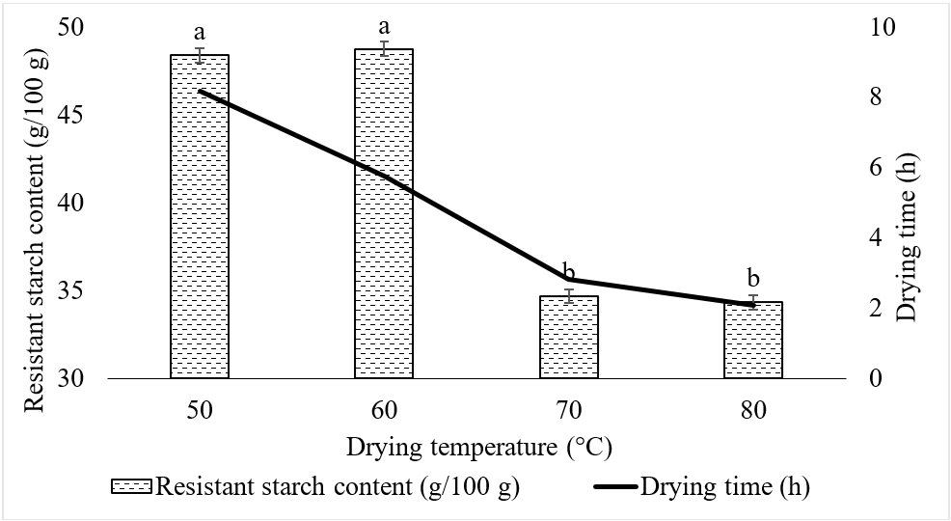
Different lowercase letters (a–b) indicate significant differences among treatments (p < 0.05).
The effect of drying temperature on the resistant starch (RS) content of green banana flour is shown in Figure 1. Drying temperature significantly affected the RS content (p < 0.05). As the drying temperature increased from 50 to 60°C, the RS content increased and reached the highest value at 60°C (48.75 g/100 g dry matter). Further increasing the temperature to 70 and 80°C resulted in a significant reduction in RS content, with the lowest value observed at 80°C (34.33 g/100 g dry matter).
The increase in RS content at 60°C may be attributed to moisture removal, which promotes the reassociation of amylose and amylopectin chains, favoring the formation of retrograded resistant starch (RS3) (Ashwar et al., 2016). In contrast, higher drying temperatures may disrupt the crystalline structure of starch, reduce molecular ordering and increase its susceptibility to enzymatic hydrolysis, thereby decreasing RS content (Khoozani et al., 2019). A similar trend was reported by Kumar et al. (2018), who found that drying at 55°C produced the highest RS content.
3.2 Effect of Green Banana Flour substitution on cookie textural properties
The effect of green banana flour (GBF) substitution on cookie textural properties is shown in Table 1. Increasing the substitution level significantly reduced hardness and fracturability (p < 0.05). No significant differences were observed between the control and cookies containing 20% GBF. The reduction in textural properties at higher substitution levels was mainly attributed to the lower gluten content and the different physicochemical properties of green banana starch, which weakened the dough structure, as also reported by Candal and Erbas (2019). Therefore, the 20% substitution level was selected as the best formulation for subsequent sensory evaluation.
Table 1. Textural properties of cookies prepared with GBF substitution
No. | GBF substitution ratio (%) | Hardness (gf) | Fracturability (gf/mm)
1 | Control | 920.8 ± 20.8ª | 2675.2 ± 100.3ª
2 | 20 | 918.3 ± 10.8ª | 2671.1 ± 87.6ª
3 | 40 | 522.8 ± 33.2^{b} | 1802.2 ± 100.6^{b}
4 | 60 | 173.2 ± 12.4^{c} | 1301.3 ± 101.5^{c}
Different lowercase letters (a–b) indicate significant differences among treatments (p < 0.05).
  - Effect of Green Banana Flour substitution on sensorial characteristics of cookies
Figure 3. Effect of green banana flour substitution on sensorial characteristics of cookies.
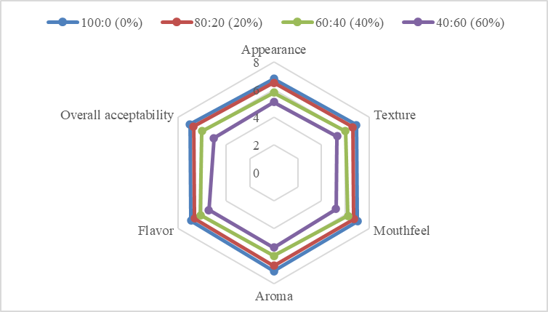
The sensory evaluation results are presented in Figure 3. Cookies containing 20% green banana flour (GBF) showed sensory scores comparable to those of the control for appearance, texture, mouthfeel, aroma, flavor, and overall acceptability, with no significant differences (p > 0.05). In contrast, increasing the substitution level to 40% and 60% significantly reduced overall sensory acceptance (p < 0.05). The lower sensory scores at higher GBF levels were mainly attributed to undesirable changes in color and texture caused by reduced gluten content and the different physicochemical properties of green banana flour. Similar trends have been reported for resistant starch-enriched bakery products (Pham Van Hung et al., 2021). Overall, the 20% GBF substitution level provided the best balance between sensory quality and nutritional improvement and was selected as the optimum formulation for subsequent experiments.
3.4 Effect of baking conditions on cookies moisture
The effects of baking temperature and time on cookie moisture content are shown in Table 2. Moisture content decreased significantly with increasing baking temperature and time (p < 0.05), from 4.77% at 150°C for 10 min to 0.42% at 180°C for 15 min, with only slight additional reductions after 20 min. The moisture loss was attributed to enhanced water evaporation during baking, whereas excessive temperature or prolonged baking may adversely affect product structure through rapid crust formation. Among the conditions evaluated, baking at 165°C for 15 min produced cookies with a moisture content of 0.78%, providing a desirable balance between crispness and structural integrity. This observation agrees with Liu et al. (2024), who reported that increasing baking temperature and time accelerated moisture loss in cookies.
Table 2. Effect of baking condition on moisture content of cookies
No. | Baking time (min) | Baking temperature (°C) | Cookie moisture (%)
1 | 10 | 150 | 4.77 ± 0.06
2 | 10 | 165 | 4.61 ± 0.02
3 | 10 | 180 | 3.18 ± 0.18
4 | 15 | 150 | 1.02 ± 0.03
5 | 15 | 165 | 0.78 ± 0.04
6 | 15 | 180 | 0.42 ± 0.04
7 | 20 | 150 | 0.2 ± 0.02
8 | 20 | 165 | 0.17 ± 0.01
9 | 20 | 180 | 0.13 ±0.03
The resulting cookies contained 15.01 g RS/100 g dry matter. In comparison, conventional wheat flour cookies generally contain less than 2.0 g RS/100 g dry matter because starch gelatinization during baking increases its susceptibility to enzymatic digestion (Birt et al., 2013). Therefore, the RS content of the developed cookies was approximately 7.5-fold higher than that of conventional cookies, demonstrating the effectiveness of GBF as an RS-rich functional ingredient.
4. Conclusion
This study demonstrated that green Cavendish banana is a promising source of resistant starch (RS) for the production of functional cookie ingredients. Drying at 60°C produced green banana flour with the highest RS content (48.75 g/100 g dry matter). Replacing 20% of wheat flour with green banana flour yielded cookies with textural and sensory properties comparable to the control, while baking at 165°C for 15 min produced cookies with low moisture content (0.78%) and a high RS content (15.01 g/100 g dry matter), approximately 7.5-fold higher than that of conventional cookies. These findings demonstrate the feasibility of incorporating RS-rich green banana flour into cookies to enhance their nutritional value while maintaining product quality, providing a value-added utilization strategy for green Cavendish bananas and supporting the development of functional bakery products.
ACKNOWLEDGEMENT:
This study was supported by Ho Chi Minh City University of Industry and Trade under Contract No. 72/HĐ-DCT/2025.
References:
Pham Van Hung, Trinh Thi My Duyen, Hoang Van Thanh, Widiastuti, D., & Nguyen Thi Hoai An (2021). Starch digestibility and quality of cookies made from acid and heat-moisture treated sweet potato starch and wheat flour composites. Journal of Food Measurement and Characterization, 15(4), 3045-3051. https://doi.org/10.1007/S11694-021-00892-Z.
Ashwar, B. A., Gani, A., Shah, A., Wani, I. A., & Masoodi, F. A. (2016). Preparation, health benefits and applications of resistant starch - A review. Starch/Staerke, 68(3-4), 287-301. https://doi.org/10.1002/star.201500064.
Birt, D. F., Boylston, T., Hendrich, S., Jane, J. L., Hollis, J., Li, L., McClelland, J., Moore, S., Phillips, G. J., Rowling, M., Schalinske, K., Paul Scott, M., & Whitley, E. M. (2013). Resistant Starch: Promise for Improving Human Health. Advances in Nutrition, 4(6), 587-601. https://doi.org/10.3945/an.113.004325.
Candal, C., & Erbas, M. (2019). The effects of different processes on enzyme resistant starch content and glycemic index value of wheat flour and using this flour in biscuit production. Journal of Food Science and Technology, 56(9), 4110. https://doi.org/10.1007/S13197-019-03880-W.
Cervini, M., Frustace, A., Garrido, G. D., Rocchetti, G., & Giuberti, G. (2021). Nutritional, physical and sensory characteristics of gluten-free biscuits incorporated with a novel resistant starch ingredient. Heliyon, 7(3), e06562. https://doi.org/10.1016/J.HELIYON.2021.E06562.
Liu, C., Li, J., Wu, C., Zhao, X., & Zheng, X. (2024). Cookie Baking Process Optimization and Quality Analysis Based on Food 3D Printing. Journal of Northeast Agricultural University (English Edition), 31(1), 61-73. https://www.aeeisp.com/jnau/en/article/id/4236b62c-5296-4441-8116-2a38cdedb17a.
Khoozani, A. A., Bekhit, A. E. D. A., & Birch, J. (2019). Effects of different drying conditions on the starch content, thermal properties and some of the physicochemical parameters of whole green banana flour. International Journal of Biological Macromolecules, 130, 938-946. https://doi.org/10.1016/J.IJBIOMAC.2019.03.010.
Kumar, P. S., Nambi, E., Shiva, K. N., Vaganan, M. M., Ravi, I., Jeyabaskaran, K. J., & Uma, S. (2019). Thin layer drying kinetics of Banana var. Monthan (ABB): Influence of convective drying on nutritional quality, microstructure, thermal properties, color, and sensory characteristics. Journal of Food Process Engineering, 42(4), e13020. https://doi.org/10.1111/jfpe.13020.
Magon, S. M. M., Josue-Canacan, D. R., & Valleser, V. C. (2026). Harnessing biostimulants for sustainable ‘cavendish’ banana production under abiotic stress conditions: A narrative review. South Asian Journal of Agricultural Sciences, 6(5), 11-25. https://doi.org/10.22271/27889289.2026.V6.I5A.288.
Molnar, D., Velickova, E., Prost, C., Temkov, M., Ščetar, M., & Novotni, D. (2023). Consumer Nutritional Awareness, Sustainability Knowledge, and Purchase Intention of Environmentally Friendly Cookies in Croatia, France, and North Macedonia. Foods, 12(21), 3932. https://doi.org/10.3390/foods12213932.
Munir, H., Alam, H., Nadeem, M. T., Almalki, R. S., Arshad, M. S., & Suleria, H. A. R. (2024). Green banana resistant starch: A promising potential as functional ingredient against certain maladies. Food Science and Nutrition, 12(6), 3787-3805. https://doi.org/10.1002/fsn3.4063.
Oupathumpanont, O., & Wisansakkul, S. (2021). Gluten-free Pasta Products with Improved Nutritional Profile by Using Banana Flour. Journal of Food and Nutrition Research, 9(6), 313-320. https://doi.org/10.12691/JFNR-9-6-7.
Ringer, T., & Blanke, M. (2021). Non-invasive, real time in-situ techniques to determine the ripening stage of banana. Journal of Food Measurement and Characterization, 15(5), 4426-4437. https://doi.org/10.1007/S11694-021-01009-2.
Sidhu, J. S., & Zafar, T. A. (2020). Chemical composition and nutritional profile of raw and processed banana products. Handbook of Banana Production, Postharvest Science, Processing Technology, and Nutrition, 207–226. https://doi.org/10.1002/9781119528265.ch11
Zhang, L., Song, K., Gu, H., Jia, Z., Chang, J., Hong, K., & Hou, X. (2017). Effect of Citric Acid Treatment on Browning of Fresh-cut Pueraria. Chinese Journal of Tropical Crops, 38(6), 1143-1148. https://www.rdzwxb.com/EN/Y2017/V38/I6/1143.

|5

