Optimization of biodiesel production via palmitic acid esterification in excess methanol using a single-hidden-layer artificial neural network
Dang Tan Hiep^{1,*}
Truong Minh Tri²
¹Faculty of Chemical Engineering, Ho Chi Minh City University of Industry and Trade
²Mientrung University of Civil Engineering
*Email: hiepdt@huit.edu.vn
ABSTRACT:
This study optimizes biodiesel production through the esterification of palmitic acid in excess methanol by integrating a single-hidden-layer Artificial Neural Network (ANN) with a Design of Experiments (DOE) approach. The optimal ANN architecture, comprising 29 TanH, 16 Linear, and 50 Gaussian neurons, was developed to model the relationship between three key process variables and fatty acid methyl ester (FAME) content. The ANN model exhibited superior predictive performance compared with conventional experimental methods, achieving a high coefficient of determination (R² = 0.9830) and a low root mean square error (RMSE = 0.2030). The prediction profiler identified a maximum FAME yield of 97.86%, demonstrating that the hybrid ANN–DOE model is a robust and reliable tool for optimizing and predicting process parameters in biodiesel synthesis.
Keywords: ANN, biodiesel, solid catalyst, palmitic acid, methanol.

1. Introduction
Economic development has heavily relied on non-renewable energy resources, particularly fossil fuels, which have led to significant environmental and health issues. As a result, developing alternative energy sources, such as biodiesel, is essential to reduce dependence on non-renewable resources (Melero J. A., 2009; Klemeš J. J., 2010). Biodiesel is widely recognized as a renewable energy alternative to fossil fuels. It typically consists of a blend of fatty acid methyl esters (FAME) and fatty acid ethyl esters (FAEE) derived from sources like vegetable oils, waste cooking oils (WCO), and animal fats, processed with either homogeneous or heterogeneous catalysts (Mansir N., 2018; Gaurav N. 2017; Hoseini S. S., 2017).
For optimization and modeling, common approaches include one-factor-at-a-time (OFAT), factorial designs (FD/FFD), response surface methodology (RSM), and/or artificial neural networks (ANN). OFAT, one of the oldest methods, investigates main effects of variables but lacks efficiency, disregarding interaction effects and often missing optimal settings. It also demands extensive time, materials, and labor due to the large number of runs required. To address these limitations, design of experiments (DOE) and ANN are frequently used in experimental science and engineering to enhance efficiency (Ferreira S. L. C., 2007; Shanmugaprakash M., 2013; Prakash N., 2008). Generally, the process involves defining the problem, selecting variables, gathering data, and optimizing the model (Montgomery D. C., 2005; Vicente G., 2007).
In this work, the optimization results from BBD for the esterification of palmitic acid in excess methanol are used as input data for the ANN to determine the optimal conditions of the independent variables for the palmitic acid methyl ester reaction. This study focuses on optimizing biodiesel production by using an ANN model based on published data of us.
2. Materials and method
2.1. Chemicals
All chemicals and procedures were conducted as described in our previous publication (Dang T. H., 2014). Methyl alcohol (anhydrous) and palmitic acid (98%), products from Sigma-Aldrich™, were of analytical reagent grade. The catalyst, Amberlite™ IR-120 (H) resin, was pre-heated at 110 °C for 48 hours to remove moisture, then placed in a desiccator before being transferred to the reactor.
2.2. Artificial neural network
Artificial neural networks (ANNs) can serve as an alternative to polynomial regression for modeling complex nonlinear relationships. ANNs consist of interconnected neurons organized into layers: an input layer, output layer, and hidden layers. In this study, a three-layer feed-forward network was used, activation transfer functions in the hidden layer, and a linear transfer function in the output layer. Activation function is a transformation of a linear combination of the input factors. The activation functions are using in this research as respectively follows:
TanH function: $f\left(x\right)= \frac{e^{2x}-1}{e^{2x}+1}$ (Eq.1)
where x is a linear combination of the input factors.
Gaussian function: $f\left(x\right)=e^{{-x}^{2}}$ (Eq.2)
where x is a linear combination of the independent variables; and the linear activation function (Eq.3) was used as the output layer activation function.
$f\left(x\right)=x$ (Eq.3)
In this work, the activation functions in the hidden layer is a combination of TanH, Linear, and Gaussian functions. JMP® Pro 17 is used optimize neural network architecture (JMP documentation, 2026).
2.3. Optimization of neural network architecture
A three-layer neural network (input, hidden, and output layers) was used, with a single hidden layer in this architecture. The activation function in the hidden layer is combination of the TanH, Linear, and Gaussian functions. Each input variable has three levels including low (-), center (0), and high (+). Typically, single-layer TanH, single-layer Linear, and single-layer Gaussian networks are denoted as X₁, X₂, and X₃, respectively. The output variables included R² training, standard squared error (SSE) training, R² fit, and SSE fit.
The correlation between experimental and predicted data was analyzed to evaluate the goodness of fit and prediction accuracy of the constructed models. Error metrics such as root mean square error (RMSE), standard error of prediction (SEP), relative percent deviation (RPD), and the correlation coefficient (R²) were used. The formulas for statistical analysis are provided in Eqs.(4)-(6).
$RMSE=\sqrt{\frac{\sum_{i=1}^{n}{}{({{\hat{Y}}_{i}-Y}_{i})}^{2}}{n}}$ (Eq.4)
$SEP=\frac{RMSE}{\underline{Y}}×100$ (Eq.5)
$RPD=\frac{100}{n}\sum_{i=1}^{n}{}\frac{|{{\hat{Y}}_{i}-Y}_{i}|}{|Y_{i}|}$ (Eq.6)
where, Y_{i} stands for experimental data, ${\hat{Y}}_{i}$ is the predicted data, $\underline{Y}$ and n represent for the mean value and the number of the experimental results, respectively. Typically, smaller values are expected for RMSE and SEP, while a higher value of R² is preferred (Sarve A., 2015).
3. Results and discussions
3.1. Optimization of the neural network architecture
This DOE was evaluated using 15 unoptimized ANNs with SLS regression. Main and interaction effects with p-values less than 0.05 were considered significant and retained in the regression model. The desirability of R² training was maximized, while SSE training, R² fit, and SSE fit were minimized, as shown in Figure 1.
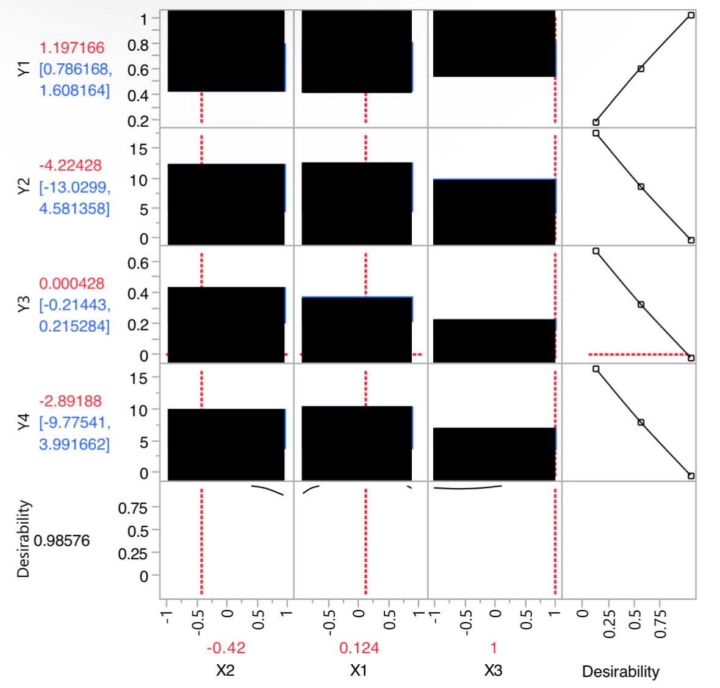
Figure 1. The output parameters of the ANN-DOE hybrid model were optimized using standard least squares regression and a prediction profiler to determine the optimal ANN configuration dexamethasone
Accordingly, the ANN-DOE model reaches optimal performance when combining three activation functions with specific network nodes as follows: 29 TanH nodes, 16 Linear nodes, and 50 Gaussian nodes in a single hidden layer.
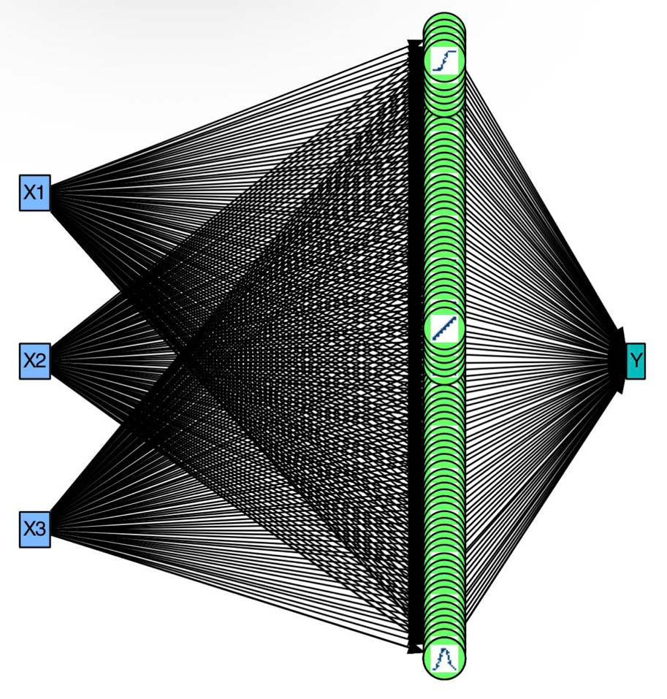
Figure 2. The optimal ANN architecture consists of a single-layer ANN with 29 TanH neurons, 16 Linear neurons, and 50 Gaussian neurons
3.2. Optimization of biodiesel production
The architectured ANN was applied to predict the biodiesel production in this case. The Box-Behnken Design was used for biodiesel production optimization. The center points were triplicated, and its average value was placed in the last row in Table 1.
Table 1. Experimental and predicted results of biodiesel yield via ANN model.
Pattern | X₁ | X₂ | X₃ | FAME content (%)
 |  |  |  | Exp.^{(*)} |  | ANN
− − 0 | -1 | -1 | 0 | 94.47 |  | 94.49
− + 0 | -1 | 1 | 0 | 96.13 |  | 96.11
+ − 0 | 1 | -1 | 0 | 95.65 |  | 95.68
+ + 0 | 1 | 1 | 0 | 94.85 |  | 94.81
0 − − | 0 | -1 | -1 | 94.59 |  | 95.04
0 − + | 0 | -1 | 1 | 96.95 |  | 96.91
0 + − | 0 | 1 | -1 | 95.91 |  | 95.97
0 + + | 0 | 1 | 1 | 96.04 |  | 96.04
− 0 − | -1 | 0 | -1 | 95.92 |  | 95.89
+ 0 − | 1 | 0 | -1 | 95.85 |  | 95.84
− 0 + | -1 | 0 | 1 | 95.76 |  | 95.79
+ 0 + | 1 | 0 | 1 | 96.02 |  | 96.05
0 0 0 | 0 | 0 | 0 | 97.75 |  | 97.86
R² |  |  |  |  | 0.9500 | 0.9830
RMSE |  |  |  |  | 0.3539 | 0.2030
SEP(%) |  |  |  |  | - | 0.21
^{(*)} taken from a previous publication (Dang T. H., 2014)
The experimental and ANN-predicted values of FAME content percentage were presented in Table 1. In which, the predicted values were generated by ANN model. The predicted results were highly correlated with those of experimental results. It means that the network was successfully trained to capture the non-linear relationships within system.
To rigorously evaluate the model’s performance, statistical indicators including the coefficient of determination (R²), root mean square error (RMSE), and standard error of prediction (SEP) were analyzed. The ANN model achieved an R² value of 0.9830, which is a noticeable improvement over the 0.9500 reported in the previous publication (Dang T. H., 2014). This indicates that the ANN model can explain 98.30% of the total variance in biodiesel yield, leaving only 1.70% as unexplained residual variance. The superiority of the ANN approach is further underscored by the sharp decline in RMSE from 0.3539 (previous study) to 0.2030 in this work. Additionally, the remarkably low SEP of 0.21% confirms the high precision and reliability of the model when predicting FAME content.
4. Conclusions
The single-hidden-layer ANN coupled with DOE successfully optimized the esterification of palmitic acid for biodiesel production. The optimal ANN architecture-comprising 29 TanH, 16 Linear, and 50 Gaussian neurons-demonstrated outstanding predictive accuracy, outperforming experimental baselines with a high R² of 0.9830 and a low RMSE of 0.2030. Using a prediction profiler, the hybrid model identified the optimal processing conditions, achieving a maximum FAME content of 97.86%. This confirms that the ANN-DOE approach is a highly robust and reliable tool for process optimization in biodiesel manufacturing.
References:
Dang, T. H., & Chen, B. H. (2014). Application of response surface methodology to optimize biodiesel production from the esterification of palmitic acid in excess methanol. Journal of Science and Technology, 53(2), 10.
Ferreira, S. L. C., Bruns, R. E., Ferreira, H. S., Matos, G. D., et al. (2007). Box-Behnken design: An alternative for the optimization of analytical methods. Analytica Chimica Acta, 597(2), 179–186.
Gaurav, N., Sivasankari, S., Kiran, G. S., Ninawe, A., & Selvin, J. (2017). Utilization of bioresources for sustainable biofuels: A review. Renewable and Sustainable Energy Reviews, 73, 205–214.
Hoseini, S. S., Najafi, G., Ghobadian, B., Mamat, R., Sidik, N. A. C., & Azmi, W. H. (2017). The effect of combustion management on diesel engine emissions fueled with biodiesel-diesel blends. Renewable and Sustainable Energy Reviews, 73, 307–331.
JMP Documentation. (2026). JMP neural network methodology. https://www.scribd.com/document/520934165/JMP-Neural-Network-Methodology
Klemeš, J. J., Varbanov, P. S., Pierucci, S., & Huisingh, D. (2010). Minimising emissions and energy wastage by improved industrial processes and integration of renewable energy. Journal of Cleaner Production, 18(9), 843–847.
Mansir, N., Teo, S. H., Rashid, U., Saiman, M. I., Tan, Y. P., Alsultan, G. A., et al. (2018). Modified waste egg shell derived bifunctional catalyst for biodiesel production from high FFA waste cooking oil: A review. Renewable and Sustainable Energy Reviews, 82, 3645–3655.
Melero, J. A., Iglesias, J., & Morales, G. (2009). Heterogeneous acid catalysts for biodiesel production: Current status and future challenges. Green Chemistry, 11(9), 1285–1308.
Montgomery, D. C. (2005). Design and analysis of experiment (6th ed.). John Wiley & Sons.
Prakash, N., Manikandan, S. A., Govindarajan, L., & Vijayagopal, V. (2008). Prediction of biosorption efficiency for the removal of copper(II) using artificial neural networks. Journal of Hazardous Materials, 152(3), 1268–1275.
Sarve, A., Sonawane, S. S., & Varma, M. N. (2015). Ultrasound assisted biodiesel production from sesame (Sesamum indicum L.) oil using barium hydroxide as a heterogeneous catalyst: Comparative assessment of prediction abilities between response surface methodology (RSM) and artificial neural network (ANN). Ultrasonics Sonochemistry, 26, 218–228.
Shanmugaprakash, M., & Sivakumar, V. (2013). Development of experimental design approach and ANN-based models for determination of Cr(VI) ions uptake rate from aqueous solution onto the solid biodiesel waste residue. Bioresource Technology, 148, 550–559.
Vicente, G., Martínez, M., & Aracil, J. (2007). Optimisation of integrated biodiesel production: Part I. A study of the biodiesel purity and yield. Bioresource Technology, 98(9), 1724–1733.

Author’s biology:
Dang Tan Hiep^{1,*}
Truong Minh Tri²
¹Faculty of Chemical Engineering, Ho Chi Minh City University of Industry and Trade
²Mientrung University of Civil Engineering
*Email: hiepdt@huit.edu.vn

Received date: April 22, 2026
Revised date: May 9, 20266
Accepted for publication date: May 16, 2026

Tối ưu hóa quá trình sản xuất nhiên liệu sinh học từ phản ứng este hóa acid palmitic khi có dư methanol bằng mạng thần kinh nhân tạo (ANN) một lớp ẩn
Đặng Tấn Hiệp^{1*}
Trương Minh Trí²
¹Khoa Công nghệ Hóa học, Trường Đại học Công Thương TP.Hồ Chí Minh
²Trường Đại học Xây dựng miền Trung
*Email: hiepdt@huit.edu.vn
Tóm tắt:
Nghiên cứu này nhằm tối ưu hóa quá trình sản xuất nhiên liệu sinh học thông qua phản ứng este hóa acid palmitic khi dư methanol sử dụng mạng thần kinh nhân tạo (ANN) một lớp ẩn, kết hợp với phương pháp thiết kế thí nghiệm. Cấu trúc ANN tối ưu được xây dựng với sự kết hợp của 29 thần kinh, hàm kích hoạt TanH, 16 thần kinh tuyến tính (Linear) và 50 thần kinh Gaussian. Mô hình ANN đạt độ chính xác dự đoán vượt trội so với các phương pháp thiết kế thí nghiệm, với R² đạt 0,9830 và RMSE thấp hơn, đạt 0,2030. Hiệu suất FAME cực đại đạt 97,86%, chứng minh rằng mô hình kết hợp giữa ANN và DOE là một phương pháp hoàn toàn phù hợp trong hướng nghiên cứu này.
Từ khóa: ANN, nhiên liệu sinh học, xúc tác rắn, axit palmitic, methanol.

