Numerical assessment of ocean current and acidification effects on CO₂ bubble leakage from shallow subsea storage
Pham Hoang Huy Phuoc Loi^{1,2,*}
¹Faculty of Chemical Engineering, Ho Chi Minh City University of Technology
²Vietnam National University, Ho Chi Minh City, Vietnam
*Email: phhloi@hcmut.edu.vn
Abstract:
Carbon capture and storage (CCS) is a critical strategy for mitigating greenhouse gas emissions. Although subsea CO₂ storage offers substantial potential, the risk of gas leakage and subsequent bubble plume formation in shallow waters poses a serious threat to marine ecosystems by inducing localized acidification. This study employs Computational Fluid Dynamics (CFD), using the Euler–Euler multiphase model, to simulate the ascent and dissolution of CO₂ bubbles under the influence of ocean currents. The model was validated against data from the QICS field experiment. The results indicate that, when mass transfer through dissolution is activated, bubble size decreases significantly, reaching a range of 2.00–9.91 mm at 30 cm above the seabed, compared with the initial maximum diameter of 12 mm. This reduction in bubble volume slows the rising velocity of the bubbles and leads to a higher concentration of dissolved CO₂ in the benthic layer, thereby posing potentially severe ecological risks to marine environments.
Keywords: CO₂ bubbles, current, ocean acidification, leakage, computational fluid dynamics.
1. Introduction
The exponential increase in anthropogenic CO₂ emissions is accelerating global climate change (IPCC, 2005). To maintain atmospheric CO₂ below the safe boundary of 350 ppm (Wennersten et al., 2015), Carbon capture and storage (CCS) technology has been widely deployed (Rockstrom et al., 2009). However, the risk of CO₂ leakage from shallow subsea storage reservoirs (depths < 500m) generates highly buoyant gaseous bubble plumes with immense ecotoxicological risks (Brewer et al., 2002; Haugan & Drange, 1992).
As CO₂ bubbles ascend, they dissolve into seawater, initiating complex ocean acidification mechanics that lower pH, increase pCO₂, and elevate the toxicity of heavy metals for marine organisms (Brewer et al., 2002; Haugan & Drange, 1992). The QICS field experiment at Ardmucknish Bay (Scotland) recorded leaked CO₂ bubbles with diameters ranging from 2 mm to 12 mm, ascending at velocities of 0.2 to 0.45 m/s with complex morphological changes (Sellami et al., 2015). To overcome the limitations of previous analytical models (which often ignored horizontal ocean currents and interphase mass transfer kinetics), this study utilizes the ANSYS Fluent software suite to establish a comprehensive computational fluid dynamic(CFD) model to evaluate the hydrodynamics of the bubble plume under the influence of currents and mass transfer.
2. Numerical Models
2.1. Euler-Euler multiphase model
The complex physical interactions between the CO₂ bubble plume (dispersed phase) and seawater (continuous phase) are resolved using the Eulerian-Eulerian multiphase approach. This method calculates the spatially averaged volume fraction of each phase within the computational grid.
2.2. Drag force and Tomiyama lift force
The CO₂ bubbles do not maintain a fixed spherical shape but deform continuously under pressure and fluid shear forces. To simulate this morphological evolution, Universal Drag Laws are applied, categorizing drag into three distinct regimes: viscous, distorted bubble, and strongly deformed cap. Simultaneously, the horizontal dispersion of the plume caused by transverse ocean currents is governed by lift forces. The Tomiyama lift model is utilized to capture the counter-intuitive "lift inversion" phenomenon, accurately predicting the wide lateral spread of the gas plume instead of an artificially narrow, cylindrical plume.
2.3. Turbulence nodel
The realizable k-$ε$ turbulence model is employed to capture the massive hydrodynamic instability and chaotic fluid mixing caused by the seawater shear current and rapid bubble ascent.
2.4. Mass transfer and dissolution
The physical dissolution of CO₂ bubbles into water is driven by the concentration gradient at the gas-liquid boundary interface and strictly follows Henry's law.
3. Simulation setup and boundary conditions
The spatial computational domain is a massive rectangular cuboid representing the seabed, measuring 100 m (Length) x 20 m (Width) x 9 m (Height) (Dewar et al., 2015). The assumed leakage zone comprises 35 circular geological pockmarks (16.78 cm in diameter each) spatially distributed over a 5 m x 15 m area on the seafloor. The constant mass release rate of the CO₂ gas is defined as 0.00036 kg/s. Figure 1 is generated with Design Modeller-ANSYS Workbench. The coordinate origin is set at the seabed floor.

Figure 1. A cuboids shape of computational domain

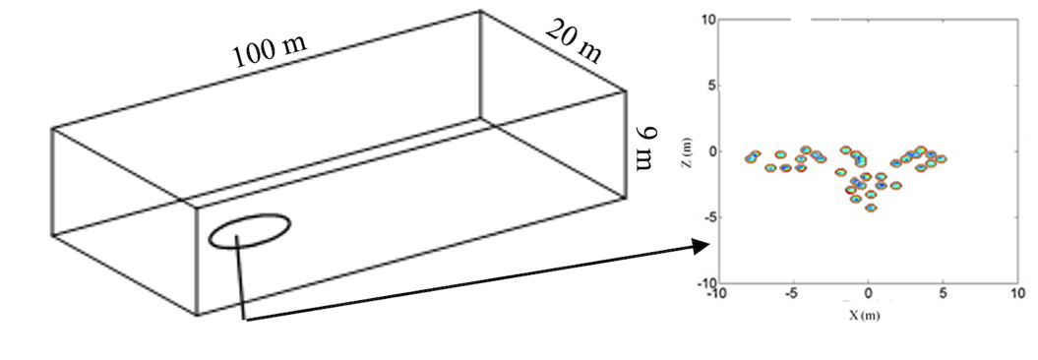

Boundary conditions are rigorously defined:
- Inlet: The ocean current velocity follows a natural logarithmic profile (ranging from 0.03 to 0.05 m/s) to accurately replicate the viscous shear stress of the benthic boundary layer.
- Open Boundaries: The downstream outflow, lateral transverse boundaries, and upper free surface are set to zero-diffusion or symmetry conditions to simulate an infinite open ocean space.
- Wall: A strict no-slip wall function is applied to the seabed floor.

4. Results and discussions
4.1. Grid dependency
To prove numerical independence, three mesh architectures (coarse, medium, fine) were tested. Figure 2 shows the predicted ascent speeds of the bubbles aligned almost flawlessly across the meshes. The medium mesh (740,206 cells) provides the optimal balance between high-fidelity scientific precision and computational processing efficiency, and was thus selected as the standard configuration.

Figure 2. Study of mesh dependency
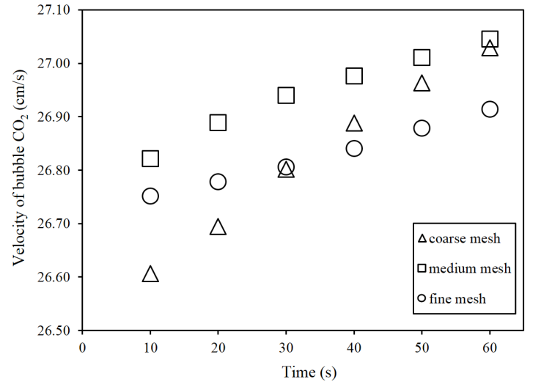
4.2. Current velocity distribution
The velocity contours definitively confirmed that the model accurately replicated the shear forces caused by seabed friction as shown in Figure 3. The fluid velocity drops to near zero adjacent to the sea floor and recovers logarithmically to 0.05 m/s at the surface, consistently matching the real environmental conditions measured in Ardmucknish Bay.
Figure 3. Countour of the shear velocity distribution of current

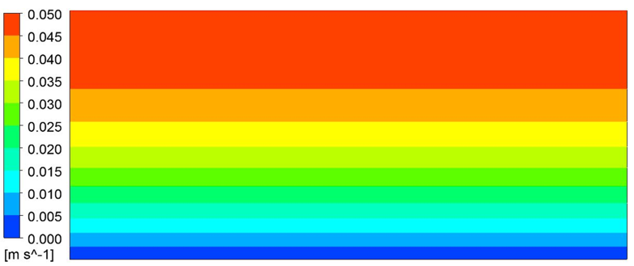

4.3. Bubble size distribution
Figure 4 shows the prediction of bubble size at 60 s after the beginning of the release. Upon activating the mass transfer module, the morphological evolution of the bubble plume changes fundamentally. Measured at a horizontal plane exactly 30 cm above the seabed, the CO₂ bubble diameter shrinks drastically from the initial size (12 mm) down to a highly constrained range of 2.0 mm to 9.91 mm. This rapid volume reduction directly decreases the buoyant lift force, severely decelerating the bubbles' vertical ascent. Consequently, the total physical residence time of the gas in the deepest strata increases, heavily localizing the acidification zone immediately above the benthic sediments.

Figure 4. Prediction of bubble size distribution up to 30 cm from the sea floor

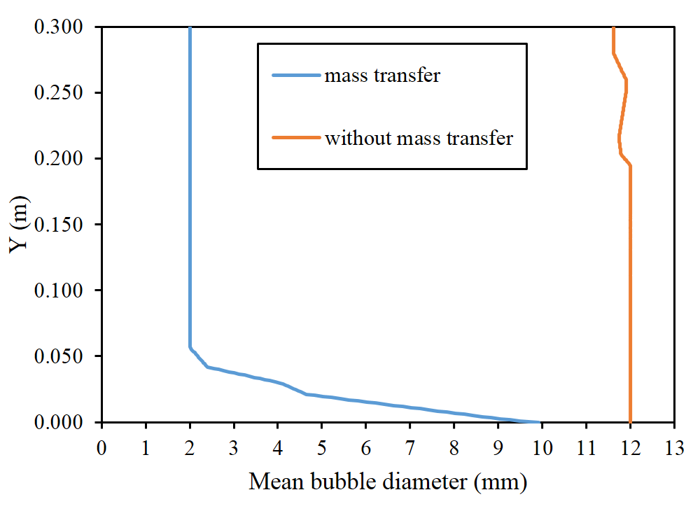
5. Conclusions
The study successfully utilized an advanced CFD framework (Euler-Euler) coupled with mass transfer kinetics, advanced drag, and lift models to replicate the leakage behavior of CO₂ bubble plumes in shallow marine environments. Incorporating both benthic seabed friction and physical chemical dissolution (Henry's law) is crucial: it proves unequivocally that the majority of CO₂ will dissolve and remain trapped near the ocean floor (bubbles rapidly shrink below 10 mm within the first 30 cm) rather than dispersing safely to the surface. This finding emphasizes that utilizing surface-level gas detectors to monitor CCS leaks is largely ineffective; instead, massive distributed networks of benthic chemical sensors must be deployed directly across the seafloor.

Acknowledgement:
The author acknowledges Ho Chi Minh City University of Technology (HCMUT), VNU-HCM for supporting this study.

References:
Brewer P. G., Peltzer E. T., Friederich G., Rehder G. (2002). Experimental determination of the fate of rising CO₂ droplets in seawater. Environmental Science and Technology, 36(24), 5441-5446.
Dewar M., Sellami N., & Chen B. (2015). Dynamics of rising CO₂ bubble plumes in the QICS field experiment: Part 2 - Modelling. International Journal of Greenhouse Gas Control, 38, 52-63.
Haugan P. M., & Drange H. (1992). Sequestration of CO₂ in the deep ocean by shallow injection. Nature, 357(6376), 318-320.
IPCC (2005). IPCC special report on carbon dioxide capture and storage, prepared by Working Group III of the IPCC. Cambridge University Press.
Rockstrom J., Steffen W., Noone K., Persson A., Chapin F. S. et al. (2009). A safe operating space for humanity. Nature, 461(7263), 472-475.
Sellami N., Dewar M., Stahl H., & Chen B. (2015). Dynamics of rising CO₂ bubble plumes in the QICS field experiment: Part 1 - The experiment. International Journal of Greenhouse Gas Control, 38, 44-51.
Wennersten R., Sun Q., & Li H. (2015). The future potential for carbon capture and storage in climate change mitigation - An overview from perspectives of technology, economy and risk. Journal of Cleaner Production, 103, 724-736.

Author’s biology
Pham Hoang Huy Phuoc Loi^{1,2,*}
¹Faculty of Chemical Engineering, Ho Chi Minh City University of Technology
²Vietnam National University, Ho Chi Minh City, Vietnam
*Email: phhloi@hcmut.edu.vn

Received date: April 18, 2026
Revised date: April 22, 2026
Accepted for publication date: May 7, 2026

Đánh giá số học về ảnh hưởng của dòng chảy và sự axit hóa đại dương đến sự rò rỉ bọt khí Co₂ trong các khu lưu trữ dưới đáy biển nông
Phạm Hoàng Huy Phước Lợi^{1,2*}
¹Khoa Kỹ thuật Hóa học, Trường Đại học Bách khoa TP.Hồ Chí Minh
² Đại học Quốc gia TP.Hồ Chí Minh
*Email: phhloi@hcmut.edu.vn
Tóm tắt:
Thu hồi và lưu trữ cacbon là một chiến lược trọng yếu để giảm thiểu phát thải khí nhà kính. Mặc dù việc lưu trữ CO₂ dưới biển mang lại tiềm năng to lớn, rủi ro rò rỉ khí tạo thành các chùm bọt khí ở vùng nước nông lại gây ra mối đe dọa nghiêm trọng cho các hệ sinh thái biển bằng cách gây ra sự axit hóa cục bộ. Nghiên cứu này sử dụng phương pháp mô phỏng Động lực học lưu chất thông qua mô hình đa pha Euler-Euler để mô phỏng quá trình nổi lên và hòa tan của các bọt khí CO₂ dưới tác động của dòng hải lưu. Mô hình được kiểm chứng dựa trên dữ liệu thực nghiệm, kết quả cho thấy khi quá trình chuyển khối (hòa tan) diễn ra, kích thước bọt khí thu nhỏ đáng kể (giảm xuống còn 2,0 mm - 9,91 mm ở độ cao 30 cm so với đáy biển) so với giới hạn tối đa ban đầu là 12 mm. Sự giảm thể tích này làm chậm vận tốc nổi lên của bọt khí, gây ra sự tích tụ nồng độ CO₂ hòa tan cao ở tầng đáy, từ đó dẫn đến những rủi ro sinh thái nghiêm trọng.
Từ khóa: bọt khí Co₂, dòng hải lưu, axit hóa đại dương, rò rỉ, mô phỏng động lực học lưu chất.

